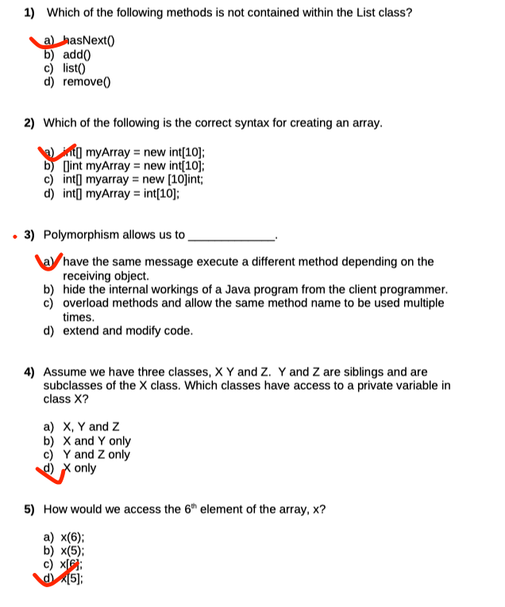

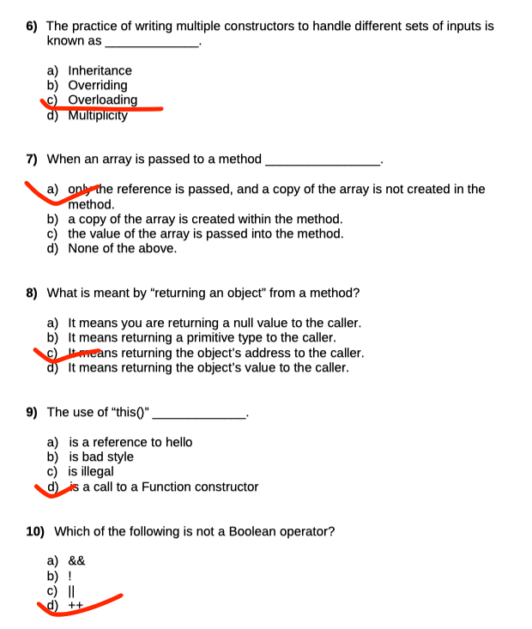

Using Scanner Class Without Import (3 Marks)

Explain how a program could use class Scanner without importing it. (refer to textbook or lecture slides).

A program can use the Scanner class without importing it explicitly if the program references it using its fully qualified name. The fully qualified name includes the package and class name. The Scanner class is part of the java.util package, so the fully qualified name would be java.util.Scanner.